**Ecosystems Chart 1–Meeting our target of protecting more land than we use by 2025**

As of FY23, Microsoft has contracted to protect 17,439 acres of land, and 15,849 acres were designated as permanently protected.

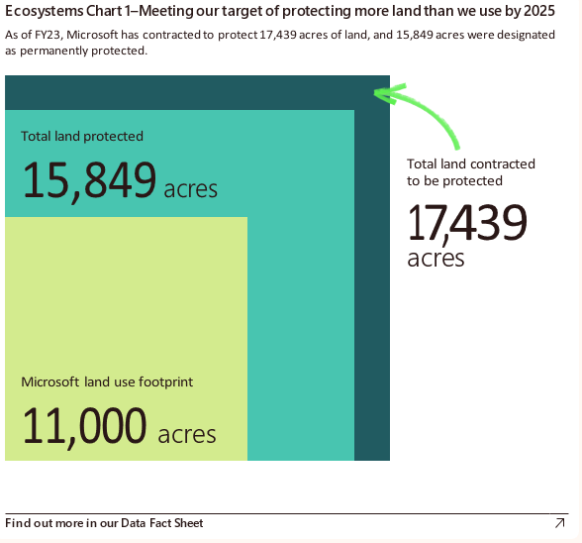

Graph showing the progress towards meeting the target of protecting more land than used by 2025. It shows Microsoft's land use footprint, totalling 11,000 acres, with the total land already protected amounting to 15,849 acres. Additionally, there are 17,439 acres of land contracted to be protected.